Project Name: Toxics Release Inventory

**Contents**

IS631-Enterprise Database Management........................................................................................1

1) INTRODUCTION ..............................................................................................................................2

2) Size of the Database: ..........................................................................................................................3

3) Entities:...............................................................................................................................................3

4) Tools/Platform to be used:..................................................................................................................3

5) DATA ELEMENT DICTINONARY.................................................................................................4

6) ER Diagram:-..................................................................................................................................7

7)SQL Queries & Explanation:- .............................................................................................................8

8)Snapshots Of Results:-.......................................................................................................................10

9) Reference..........................................................................................................................................11

**1) INTRODUCTION**

The dataset which we have considered is the Toxics Release Inventory compiled by the U.S. Environment Protection Agency (EPA). The dataset contains the information of over 53,000 facilities across the United States which enlists the quantities of chemicals managed through disposal or other release, recycling, energy recovery or treatment.

Approximately 6,300 facilities reported hazardous waste generation to RCRA BR* and also reported

to TRI in 2013. That is, 24% of about 25,900 facilities reporting hazardous waste generation to RCRA BR also reported to TRI and 29% of about 21,600 TRI filers in RY2013 also reported hazardous

waste generation to RCRA. The goal of EPA’s Toxics Release Inventory (TRI) Program is to

empower citizens and other TRI stakeholders through information about how toxic chemicals are managed. Using TRI data and EPA’s suite of TRI-related tools, one can:

• Identify potential environmental concerns and gain a better understanding of potential

• risks;

• Identify priorities and opportunities to work with industry, government and

• communities to reduce toxic chemical releases and potential risks associated with them;

• Provide the members of your community with information and insights regarding toxic

• chemical releases and waste management practices in the community;

• Make informed decisions on the consequences of such practices and take action; and

• Establish reduction targets and measure progress toward those targets.

The key factors that we have considered when we analysed the TRI dataset:

• Toxicity - The level of toxicity varies among the covered chemicals; data on amounts of the chemicals alone are inadequate to reach conclusions on health-related risks.

• Regulation by Environmental Statutes - Regulatory controls apply to many of the releases reported; reporting facilities must comply with environmental standards under statutes like the Clean Air Act Chemical.

• On-Site Waste Management - Many options for managing wastes are subject to stringent technical standards and exacting state and federal regulatory oversight.

• Off-Site Waste Management - Some TRI reporters send chemicals off-site in waste to be managed at specialized waste management facilities that are also subject to TRI reporting requirements. Since both the facilities sending waste and the facilities receiving waste report

to TRI.

**2) Size of the Database:**

The size of our database is around 2.75 GB. In this database there are around 2.4+ million records and there are 102 attributes.

**3) Entities:**

We have 7 entities which are named trius (12 attributes), chem_doc (9 attributes), potw (3 attributes), doc_onsite (10 attributes), fac_info (13 attributes), doc_summ (14 attributes), doc_offsite (32 attributes)

**4) Tools/Platform to be used:**

This project has been implemented using MS SQL Server.

**DATA ELEMENT DICTIONARY**

Attributes for trius

1. doc_ctrl_num bigint

2. year int

3. tri_facility_id nvarchar(40)

4. PARENT_COMPANY_NAME nvarchar(255)

5. PARENT_COMPANY_DB_NUMBER nvarchar(255)

6. Primary_ic nvarchar(255)

7. ic_2 nvarchar(255)

8. ic_3 nvarchar(255)

9. ic_4 nvarchar(255)

10. ic_5 nvarchar(255)

11. ic_6 nvarchar(255)

Attributes for potw:

1. doc_ctrl_num bigint

2. TRANSFERS_FOR_RELEASE float

3. TRANSFERS_FOR_TREATM float

Attributes for chem_doc:

1. doc_ctrl_num bigint

2. Chemical nvarchar(255)

3. COMPOUND_ID nvarchar(255)

4. CLEAR_AIR_ACT_CHEMICAL nvarchar(255)

5. CLASSIFICATION nvarchar(255)

6. Metal nvarchar(255)

7. METAL_CATEGORY float

8. CARCINOGEN nvarchar(255)

9. FORM_TYPE nvarchar(255)

Attributes for doc_onsite:

1. doc_ctrl_num bigint

2. UNIT_OF_MEASURE nvarchar(255)

3. FUGITIVE_AIR float

4. Stack_air float

5. Water float

6. UNDERGROUND_CLASS_I float

7. UNDERGROUND_CLASS_II_V float

8. RCRA_C_LANDFILLS float

9. B_OTHER_LANDFILLS float

10. LAND_TREATMENT float

11. SURFACE_IMPOUNDMENT float

12. RCRA_C_SURFACE_IMP float

13. Other_SURFACE_IMP float

14. OTHER_DISPOSAL float

Attributes for fac_info:

1. facno int

2. tri_facility_id nvarchar(40)

3. facility_name nvarchar(80)

4. street_address nvarchar(80)

5. city nvarchar(40)

6. county nvarchar(40)

7. st nvarchar(10)

8. zip nvarchar(20)

9. bia_code nvarchar(10)

10. tribe nvarchar(120)

11. latitude float

12. longitude float

13. federal_facility nvarchar(20)

Attributes for doc_summ:

1. doc_ctrl_num bigint

2. RELEASES float

3. ON_SITE_CONTAINED_REL float

4. ON_SITE_OTHER_RELEASES float

5. OFF_SITE_CONTAINED_REL float

6. OFF_SITE_OTHER_RELEASES float

7. ENERGY_RECOVERY_ON_SITE float

8. ENERGY_RECOVERY_OFF_SITE float

9. RECYCLING_ON_SITE float

10. RECYCLING_OFF_SITE float

11. TREATMENT_ON_SITE float

12. TREATMENT_OFF_SITE float

13. PROD#_WASTE float

14. ONE_TIME_RELEASE nvarchar(255)

15. PRODUCTION_RATIO nvarchar(255)

Attributes for doc_offsite:

1. doc_ctrl_num bigint

2. UNIT_OF_MEASURE nvarchar(255)

3. M10 float

4. M41 float

5. M62 float

6. M71 float

7. M81 float

8. M82 float

9. M72 float

10. M63 float

11. M66 float

12. M67 float

13. M64 float

14. M65 float

15. M73 float

16. M79 float

17. M90 float

18. M94 float

19. M99 float

20. M20 float

21. M24 float

22. M26 float

23. M28 float

24. M93 float

25. M56 float

26. M92 float

27. M40 float

28. M50 float

29. M54 float

30. M61 float

31. M69 float

32. M95 float

**ER Diagram**

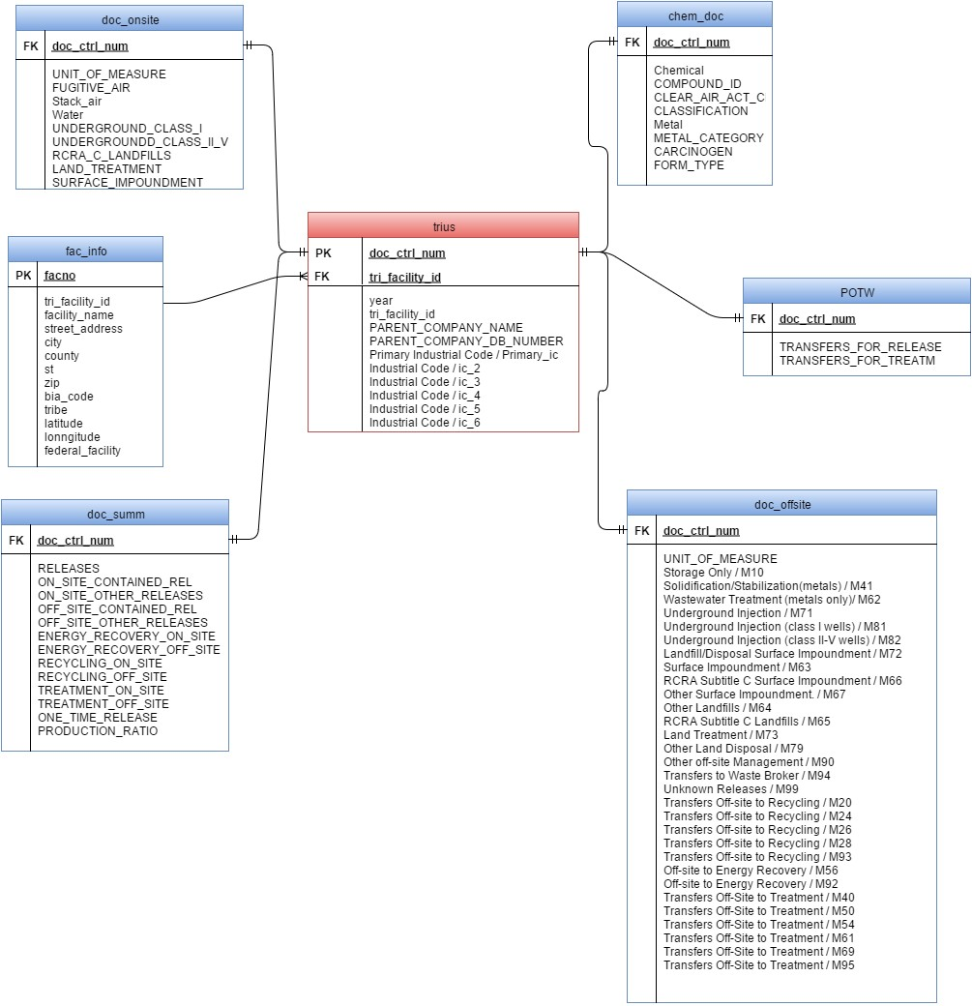

7

**SQL Queries & Explanation**

select t.year, sum(d.ON_SITE_RELEASE_TOTAL) as OnSite from trius t left join doc_onsite d on t.doc_ctrl_num = d.doc_ctrl_num

group by year order by year

This query selects and displays the total on-site toxic release and the corresponding year.

select t.year, sum(d.OFF_SITE_RELEASE_TOTAL) as OnSite from trius t left join doc_offsite d on t.doc_ctrl_num = d.doc_ctrl_num

group by year order by year

This query selects and displays the total off-site toxic release and the corresponding year.

select f.facility_name, sum(d.ON_SITE_RELEASE_TOTAL) as OnSite from trius t left join doc_onsite d on t.doc_ctrl_num = d.doc_ctrl_num

left join fac_info f on t.tri_facility_id = f.tri_facility_id where year=2013 and year=2014

group by f.facility_name order by f.facility_name

This query selects and displays the total on-site toxic release of the corresponding facility name in the year 2013 and 2014.

select t.year, f.facility_name, sum(d.ON_SITE_RELEASE_TOTAL) as OnSite from trius t left join doc_onsite d on t.doc_ctrl_num = d.doc_ctrl_num

left join fac_info f on t.tri_facility_id = f.tri_facility_id

where year=2014 and f.facility_name in ('red dog operations','uss gary works','basin electric','monsanto luling')

group by f.facility_name,t.year order by onsite desc,f.facility_name

This query selects and displays four facilities, their respective total on-site toxic release in the year

2014.

select f.facility_name, count(c.CLEAR_AIR_ACT_CHEMICAL) from trius t left join fac_info f on t.tri_facility_id = f.tri_facility_id

left join chem_doc c on t.doc_ctrl_num = c.doc_ctrl_num

where year=2014 and CLEAR_AIR_ACT_CHEMICAL='YES' group by f.facility_name

This query selects and displays the facilities and counts the total number of facilities which have the clear air act chemical.

select t.year, f.facility_name, sum(d.ON_SITE_RELEASE_TOTAL) as OnSite from trius t left join doc_onsite d on t.doc_ctrl_num = d.doc_ctrl_num

left join fac_info f on t.tri_facility_id = f.tri_facility_id

left join chem_doc c on t.doc_ctrl_num = c.doc_ctrl_num where year=2014 and CLEAR_AIR_ACT_CHEMICAL='NO' group by f.facility_name,t.year order by onsite desc,f.facility_name

This query selects and displays the facilities and counts the total number of facilities which do not have the clear air act chemical.

select t.year, f.facility_name, sum(d.ON_SITE_RELEASE_TOTAL) as OnSite from trius t left join doc_onsite d on t.doc_ctrl_num = d.doc_ctrl_num

left join fac_info f on t.tri_facility_id = f.tri_facility_id left join chem_doc c on t.doc_ctrl_num = c.doc_ctrl_num

where year=2014 and CLEAR_AIR_ACT_CHEMICAL='YES' group by f.facility_name,t.year order by onsite desc,f.facility_name

This query selects and displays the facilities and counts the total number of facilities which have the clear air act chemical and in the year 2014.

select t.year, f.facility_name, count(d.ON_SITE_RELEASE_TOTAL) as count from trius t left join doc_onsite d on t.doc_ctrl_num = d.doc_ctrl_num

left join fac_info f on t.tri_facility_id = f.tri_facility_id left join chem_doc c on t.doc_ctrl_num = c.doc_ctrl_num

where year=2013 and CLEAR_AIR_ACT_CHEMICAL='Yes' and facility_name='RED DOG OPERATIONS'

group by f.facility_name,t.year

This query selects and displays the “Red Dog Operations” and counts the total number of

facilities which have the clear air act chemical in the year 2013.

select t.year, f.facility_name, count(d.ON_SITE_RELEASE_TOTAL) as count from trius t left join doc_onsite d on t.doc_ctrl_num = d.doc_ctrl_num

left join fac_info f on t.tri_facility_id = f.tri_facility_id

left join chem_doc c on t.doc_ctrl_num = c.doc_ctrl_num

where year=2013 and CLEAR_AIR_ACT_CHEMICAL='NO' and facility_name='KENNECOTT UTAH COPPER MINE CONCENTRATORS & POWER PLANT'

group by f.facility_name,t.year

This query selects and displays the “'Kennecott Utah Copper Mine Concentrators & Power Plant”

and counts the total number of facilities which do not have the clear air act chemical in the year

2013.

select t.year, f.facility_name, count(d.ON_SITE_RELEASE_TOTAL) as count from trius t left join doc_onsite d on t.doc_ctrl_num = d.doc_ctrl_num

left join fac_info f on t.tri_facility_id = f.tri_facility_id

left join chem_doc c on t.doc_ctrl_num = c.doc_ctrl_num

where year=2013 and CLEAR_AIR_ACT_CHEMICAL='Yes' and facility_name='NEWMONT MINING CORP COPPER CANYON FACILITY'

group by f.facility_name,t.year

This query selects and displays the “'Newmont Mining Corp Copper Canyon Facility” and counts

the total number of facilities which do not have the clear air act chemical in the year 2013.

select t.year, f.facility_name, count(d.ON_SITE_RELEASE_TOTAL) as count from trius t left join doc_onsite d on t.doc_ctrl_num = d.doc_ctrl_num

left join fac_info f on t.tri_facility_id = f.tri_facility_id left join chem_doc c on t.doc_ctrl_num = c.doc_ctrl_num

where year=2013 and CLEAR_AIR_ACT_CHEMICAL='No' and facility_name='USS GARY WORKS'

group by f.facility_name,t.year

This query selects and displays the “'USS GARY WORKS” and counts the total number of

facilities which do not have the clear air act chemical in the year 2013.

**Snapshots of Results**

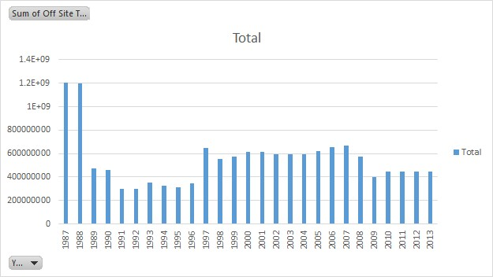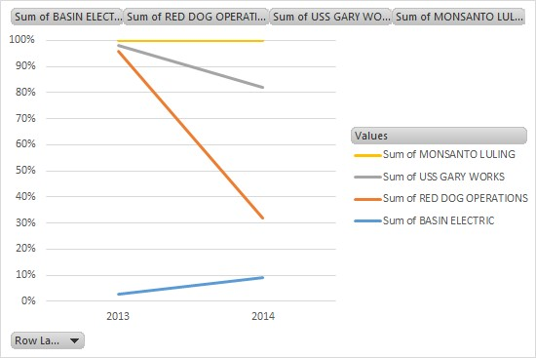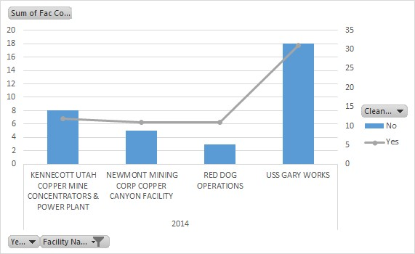

11

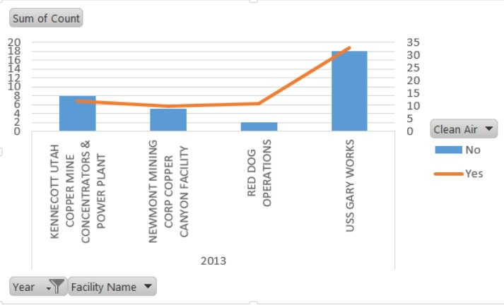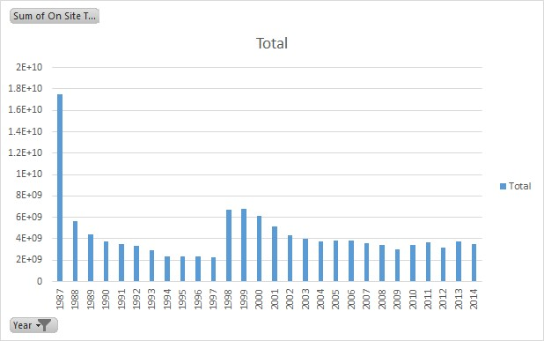

12

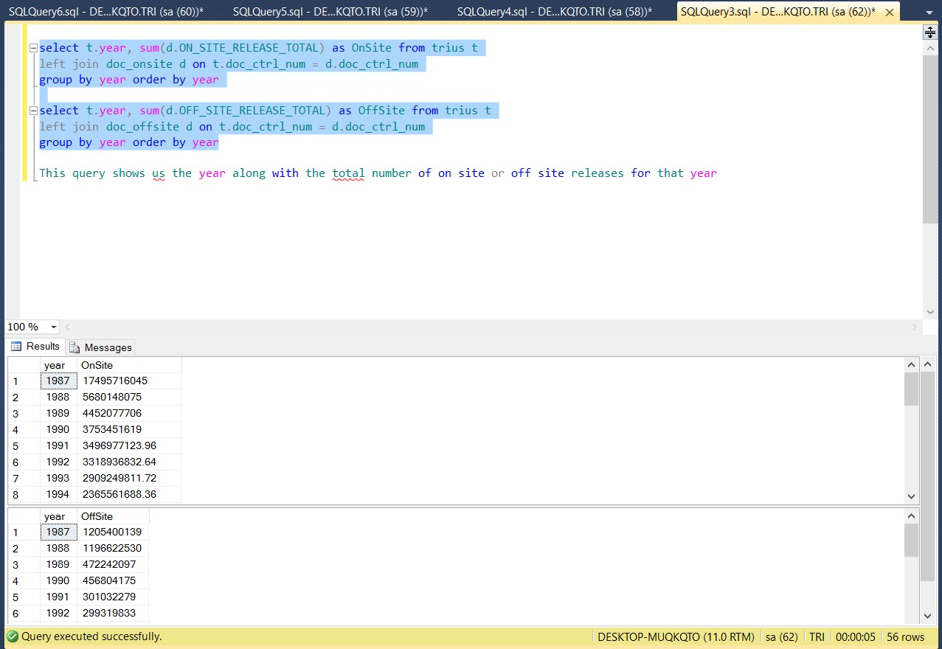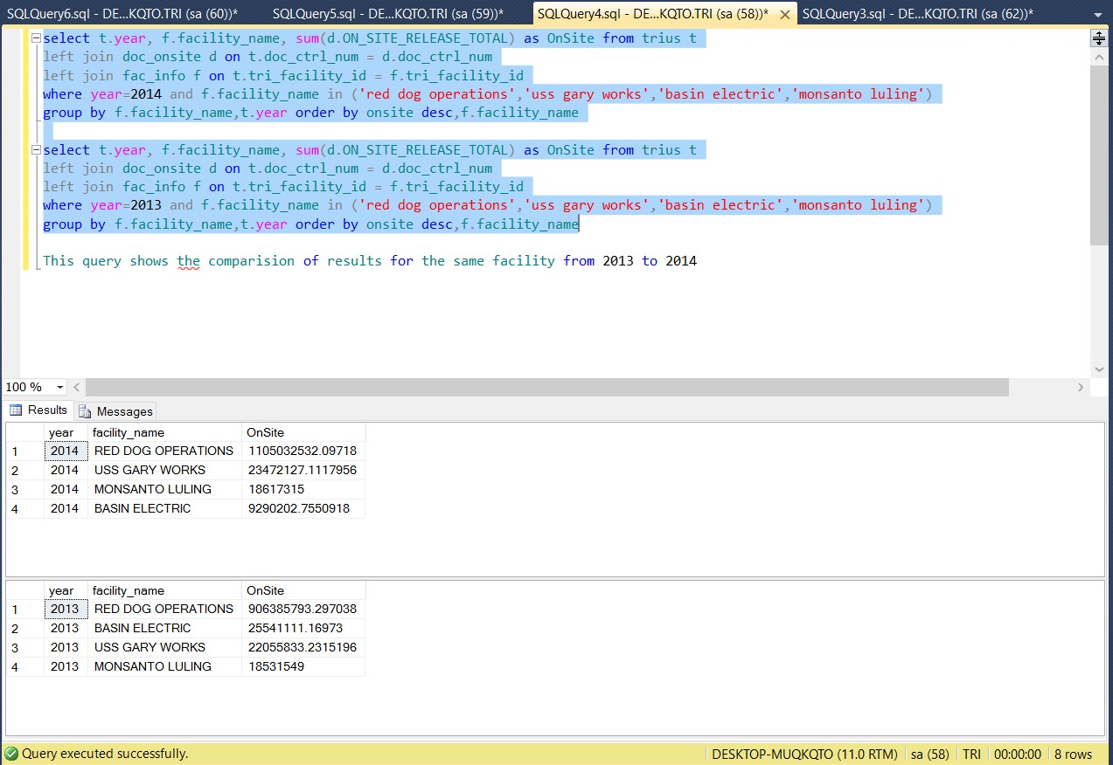

13

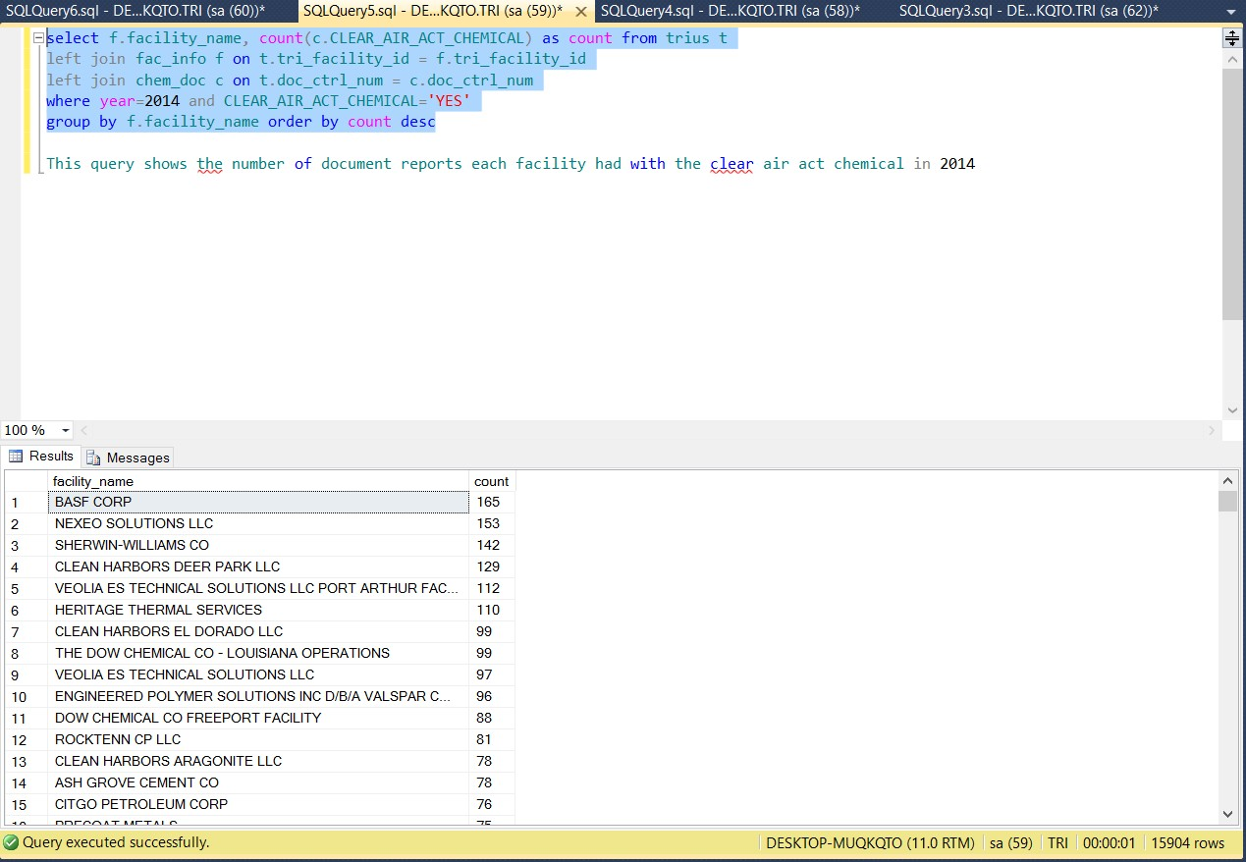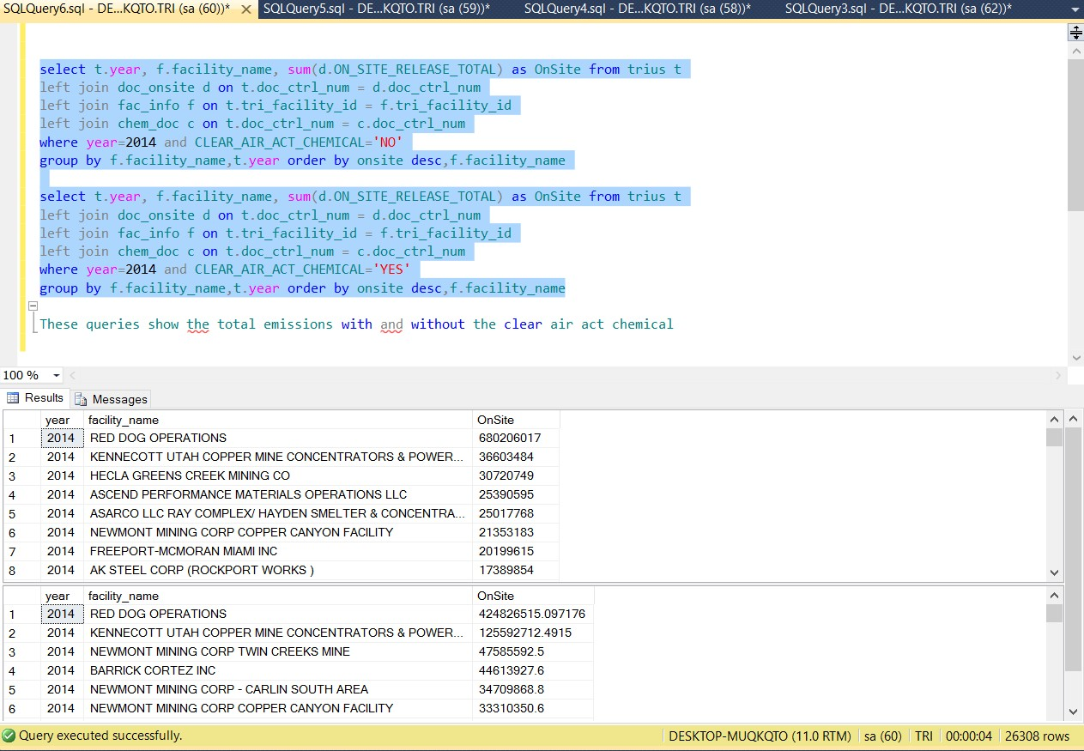

14

Inference

Although source reduction is the preferred method of reducing risk, environmentally sound recycling shares many of its advantages. Like source reduction, recycling reduces the need for treatment or disposal of waste and helps conserve energy and natural resources. Where source reduction and recycling are not feasible, waste can be treated. Disposal or other

releases of a chemical is viewed as a last resort, to be employed only if the preferred methods of waste management cannot be implemented.

**References**

<http://www.epa.gov/ttn/chief/net/2008inventory.html>